**[PROJECT NAME] – Interview Protocol**

[date]

**Stakeholders:**

[same as / copy from research brief]

**Research goal:**

[same as / copy from research brief]

**Objectives:**

1. [same as / copy from research brief]
2. ..
3. .

**Screening criteria:**

1. …
2. ..
3. .

**Scenario:**

…

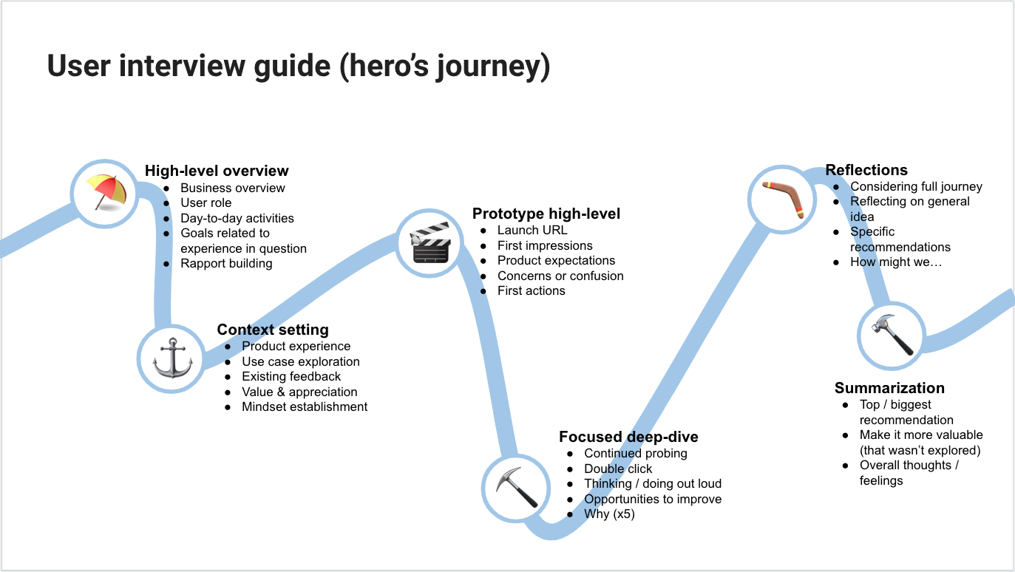

**User tasks:**

1. …
2. …
3. …
4. …
5. …
6. …
7. …
8. …
9. …
10. …
11. …
12. ….
13. …
14. …
15. …